FREE! VW Swap Meet by VWAWNY
Hosted by the Volkswagen Association of Western New York
Saturday September 14, 2019
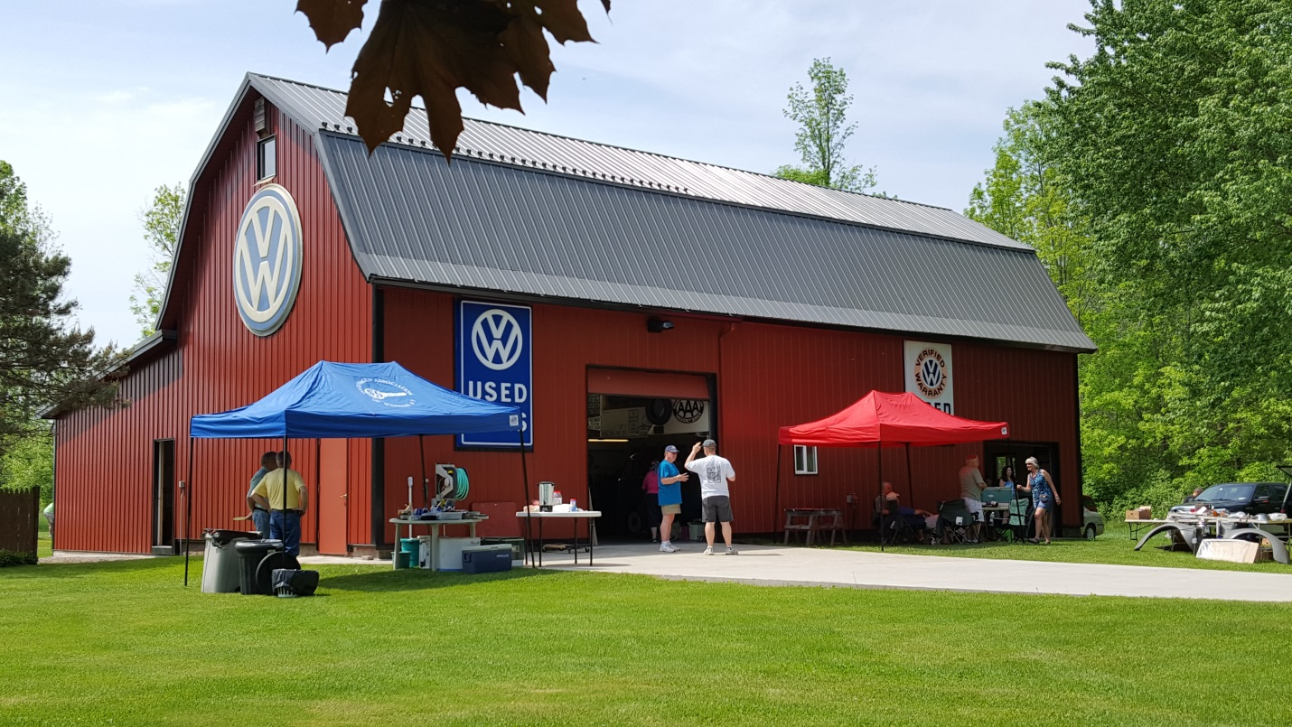LOCATION: 9184 Coleman Road, Barker, NY 14012
9:00 AM until 3:00 PM
We will serve water and hot dogs on a donation basis. If you prefer, bring your own lunch and beverages or check out the restaurant less than three miles away. The swap is for anyone buying or selling VOLKSWAGEN parts, toys, literature or cars from the last century. We need you here to make the event a success; bring whatever you have to sell. Some items that will be for sale include; a ’63 standard bus project, ’53 split window bug project, ’70 Empi Imp body (NOS) with a 1970 convertible chassis, air cooled engines rebuilt and cores, transmissions, bus and bug parts, toys, literature, old VW featured magazines and other VW memorabilia on a best offer basis.
Contact busnutbob@gmail.com with questions

